REPORT for Experiment 16
Experiment Title：Identification of microorganisms based on 16S rDNA

Instructor(s)：Pinmei Wang

Lab Location： 海工楼

Date Performed： 2024.12.28

1. Introduction
Ribosomes are the mechanisms for protein synthesis in living organisms and are necessary for survival. Bacterial ribosomes are composed of multiple ribosomal proteins and three ribose RNAs (rRNAs) (23S rRNA, 16S rRNA, and 5S rRNA; S means Svedberg unit).
With more sequencing and research of 16S rDNA, it has been recognized that:
- Nucleotide sequences are highly conserved among different bacteria;
- Conservatism and differentiation reflect the evolution of bacteria;
- Each fungal species has its own unique 16S rDNA sequence.
As a result, genes encoded in rRNA (rDNA) have been widely used to determine taxonomics, phylogenetic development (evolutionary relationships), and to estimate the rate of bacterial species differentiation. Besides, the comparison of 16S rDNA sequences can reveal the evolutionary relationship between microorganisms.
There are highly variable domains in the 16S rDNA sequences that diverge in the evolutionary process. These are usually highly conservative and encapsulated by the highly conservative area. Primers are designed to bind to conserved regions and expand variables. The DNA sequence of the 16S rDNA gene has been determined for an extremely large number of species.
We always use the Basic Local Alignment Search Tool (BLAST) to search for the homology of nucleotide sequences in the public database GenBank. BLAST is one of the most commonly used tools for comparing sequence information and querying sequences in data. BLAST accepts query sequences and searches for a given sequence data database for significant matche,generate local comparisons of varying lengths and provide descriptive parameters as well as statistical evaluations for any match.In general, if the culture traits are also compatible, >99% homology matches can be graded, while 97% to <99% matches are classified.
2. Experimental Purpose
1.Understand the principles of microorganism identification based on 16S rDNA
2.Be able to use PCR to amplify 16S rDNA genes
3.Be able to align 16S rDNA sequences to a public database and to interpret the3.alignment result
3. Equipment and Materials
EXP 16A
Primers (20 μM):27F: 5'-AGAGTTTGATCCTGGCTCAG-3'
1492R:5-GGTTACCTTGTTACGACTT-3'
Polymerase Chain Reaction (PCR) machine
2 x Taq Mixture (Taq polymerase, Tiangen, Beijing, China)
PCR tube
Gel imaging analysis system
1.5 mL tube
Pipettes and tips
E. coli genomic DNA (Provided as PCR positive control)
Centrifuge
Genomie DNA extracted by each group in Exp 14B
lce
4. Experimental Procedure
EXP 16A
- For PCR amplification of 16S rDNA, prepare the PCR reaction on ice as follows:
Reagent Volume (μl)
2 x Taq Mix 25
Primer 27F (10 μM) 1
Primer 1492R (10 μM) 1
Template DNA (~50 ng/μl) 1
ddH₂O 20
Total 50
All class just need one negative control
1）TA will prepare a PCR mix using ddH,O instead of template DNA as a negative control(阴性对照);
2) the second person should prepare another PCR mix using genomic DNA extracted by the group in Exp 14B;
3)the third person prepares the third PCR mix using direct strain culture(colonies or liquid culture) as template DNA
Demonstrators will prepare E. coli genomic DNA as positive control (阳性对照)
2. PCR cycles:
1)Denature genomic DNA at 95 °C for 5 min;
2)Denature DNA at 94 °C for 30 s, primer annealing at 51℃ for 30 s. extensionat 72 °C for 2 min, repeat for 30 cycles;
3)Final extension at 72 °C for 10 min.
4)After PCR, keep the sample at -20 °C until gel analysis,
EXP 16B
- After obtaining DNA sequence from the company, download sequencing result(unknown_DNA_for BLAST.txt) from E-mail box. The file is in FASTA format.The first line (starting with a greater-than symbol) includes a description of the sequence, and the following lines include the sequence itself.
- Navigate to the NCBI BLAST website:(http://blast.ncbi.nlm.nih.gov/Blast.cgi).
- Under “'Basic BLAST” choose the “nucleotide blast" option, which will take you to the nucleotide BLAST data entry form.
- Under “'Enter Query Sequence” use the “Browse” button (below the large white4.data entry window) to upload the file “unknown DNA for BLAST.txt” from the desktop folder containing the course files.
5.Under “Choose Search Set" select the radio button corresponding to “Others” (nr,etc.).
6.Select the blue “BLAST” button in the lower left-hand corner.
7.Examine the 4 parts of the BLAST output - the header, Graphic Summary.Descriptions, and Alignments.
5. Record and Results
Label the bands in your gel picture, print and stick the picture here:
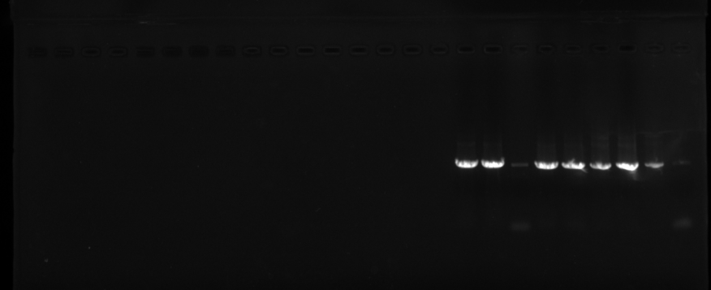

1 2 3 4
Lane 1:E.coli
Lane 2:Genomic DNA of your strain
Lane 3:Your strain culture
Lane 4:Negative control
We lost M

WORKSHEET 16
DNA template | Obtain PCR product  (Yes /No) | PCR product band size (bp)
E.coli | Yes | Can’t count
Genomic DNA of your strain | Yes | Can’t count
Your strain culture | Yes | Can’t count
Negative control | No | 0

BLAST search results for your STRAIN
Closest match genus and species | E-value | % maximum identity | % query coverage
Paenibacillus curdlanolyticus strain AFS023551 16S ribosomal RNA gene, partial sequence(OP986570.1) | 0.0 | 99.44% | 99%

6. Discussion
1) Why do we use 16S rDNA rather than 5S rDNA or 23S rDNA in molecular identification of microorganisms?

①Length and Information Content
16S rDNA has an appropriate length (around 1500 base pairs) that contains sufficient information to distinguish between different microbial species.
In contrast, 5S rDNA is too short (about 120 base pairs), which limits its ability to provide enough genetic variation for accurate identification.
23S rDNA, while longer (about 3000 base pairs), can be overly complex and may contain introns and other elements that complicate analysis.
②Conserved and Variable Regions
16S rDNA contains both highly conserved regions and hypervariable regions. The conserved regions allow for the design of universal primers that work across a wide range of organisms, while the hypervariable regions provide species-specific signatures.
5S rDNA lacks sufficient variability to differentiate closely related species.
23S rDNA also has variable regions, but its larger size makes it less convenient for routine PCR amplification and sequencing.
③Database Availability
There are extensive databases dedicated to 16S rDNA sequences, such as the Ribosomal Database Project (RDP) and SILVA. These databases facilitate easy comparison and identification of unknown sequences.
Databases for 5S and 23S rDNA are less comprehensive, making their use less practical for routine identification purposes.

2) Discuss the possible reasons, supposing no bands were seen in your gels.
①Sample Issues
(1)Insufficient DNA/RNA Amount: The concentration of the nucleic acid sample might be too low to produce visible bands.
(2)Degraded Sample: If the nucleic acid sample has degraded, it may not migrate properly or at all through the gel.
②Loading Errors
(1)Incorrect Loading: The sample might not have been loaded correctly into the wells, leading to its absence from the gel.
(2)Overloading: Overloading the well can cause the sample to overflow and spread out, resulting in faint or undetectable bands.
③Gel Preparation
(1)Improper Gel Concentration: Using an incorrect agarose concentration can affect the resolution of the bands. Too high or too low concentrations can hinder proper migration.
(2)Uneven Gel Surface: An uneven or cracked gel can lead to poor separation and visibility of the bands.
④Electrophoresis Conditions
(1)Voltage Issues: Running the gel at too low a voltage can result in insufficient migration, while too high a voltage can cause overheating and degradation of the sample.
(2)Running Time: Insufficient running time may prevent the sample from migrating far enough to form detectable bands, whereas excessive running time can cause the bands to run off the gel.

